NIST Framework for improving Critical Infrastructure Cyber Security

- OBJECTIVE: The objective of the NIST Cybersecurity Framework is to identify “a prioritized, flexible, repeatable, performance-based, and cost-effective approach” to keeping data secure.
- What is the NIST Cybersecurity Framework?
The NIST Cybersecurity Framework is a set of best practices organizations can use to keep their data secure. Created by the National Institute of Standards and Technology, the framework was designed to make cost-effective data security possible for organizations of any size.
- The Cyber security Framework consists of three main components:
- The Core
- Implementation Tiers
- Profiles

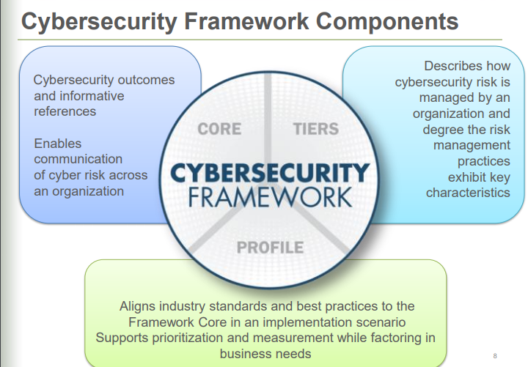

- The five Functions included in the Framework Core are:

- Identify:

The Identify Function assists in developing an organizational understanding to managing cyber security risk to systems, people, assets, data, and capabilities.
Examples of outcome Categories within this Function include:
- Identifying physical and software assets within the organization to establish the basis of an Asset Management program
- Identifying the Business Environment the organization supports including the organization's role in the supply chain, and the organizations place in the critical infrastructure sector
- Identifying cyber security policies established within the organization to define the Governance program as well as identifying legal and regulatory requirements regarding the cyber security capabilities of the organization.

- Protect:
The Protect Function outlines appropriate safeguards to ensure delivery of critical infrastructure services. The Protect Function supports the ability to limit or contain the impact of a potential cyber security event.
Examples of outcome Categories within this Function include:
- Protections for Identity Management and Access Control within the organization including physical and remote access
- Empowering staff within the organization through Awareness and Training including role based and privileged user training
- Establishing Data Security protection consistent with the organization’s risk strategy to protect the confidentiality, integrity, and availability of information

- Detect
The Detect Function defines the appropriate activities to identify the occurrence of a cybersecurity event. The Detect Function enables timely discovery of cybersecurity events.
Examples of outcome Categories within this Function include:
- Ensuring Anomalies and Events are detected, and their potential impact is understood
- Implementing Security Continuous Monitoring capabilities to monitor cybersecurity events and verify the effectiveness of protective measures including network and physical activities
- Maintaining Detection Processes to provide awareness of anomalous events

- Respond
The Respond Function includes appropriate activities to take action regarding a detected cybersecurity incident. The Respond Function supports the ability to contain the impact of a potential cybersecurity incident.
Examples of outcome Categories within this Function include:
- Ensuring Response Planning process are executed during and after an incident
- Managing Communications during and after an event with stakeholders, law enforcement, external stakeholders as appropriate
- Analysis is conducted to ensure effective response and support recovery activities including forensic analysis, and determining the impact of incidents

- Recover
The Recover Function identifies appropriate activities to maintain plans for resilience and to restore any capabilities or services that were impaired due to a cybersecurity incident. The Recover Function supports timely recovery to normal operations to reduce the impact from a cybersecurity incident.
Examples of outcome Categories within this Function include:
- Ensuring the organization implements Recovery Planning processes and procedures to restore systems and/or assets affected by cybersecurity incidents
- Implementing Improvements based on lessons learned and reviews of existing strategies.
- Internal and external Communications are coordinated during and following the recovery from a cybersecurity incident

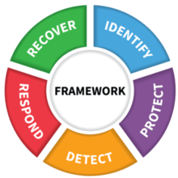

6 Steps for Implementing the NIST Cybersecurity Framework

1. Set Your Goals
The first thing you should do before implementing the NIST Framework is to set your own organizational goals regarding your data security.
What level of risk are you comfortable with? What areas of your business need protection the most?
Setting goals allows you to organize your actions, establish a scope for your security efforts, and prioritize where steps are the most important ones and should be taken first.

2. Create a Detailed Profile
Although the NIST framework is billed as a voluntary set of guidelines applicable to numerous industries, its application in your business may look different from that of your peers.
The Framework Implementation Tiers help you identify where your business needs to improve and the steps that must be taken to make those improvements a reality. The tiers are listed below:
- Tier 1: Partial - This means your cybersecurity practices are generally reactive to whatever cybersecurity event is occurring.
- Tier 2: Risk-Informed - This tier describes companies that may be aware of some risk and are regularly making plans for how to respond to that risk.
- Tier 3: Repeatable - The Repeatable tier applies to companies that have clearly outlined and regularly repeatable cybersecurity processes.
- Tier 4: Adaptive - Adaptive companies are proactive in terms of cybersecurity measures, preventing events instead of reacting to them.
It’s not essential that you move from Tier 1 to Tier 4 as quickly as possible.
In contrast, progression through the tiers should happen when it’s the smartest decision from a cost and security standpoint for your company.

3. Determine Your Current Position
Conduct an independent risk assessment so you can determine your current data security position.
A risk assessment of your current efforts reveals what’s working and what steps you need to take to get your other security efforts up to NIST standards.
One way to determine your current position is to use software tools capable of scoring your security efforts.
Train staff members on how to use these tools or partner with a third-party vendor to conduct the assessment.

4. Analyse Any Gaps and Identify the Actions Needed
Once scores are collected, they can be presented to key stakeholders in your business. With this knowledge, you are equipped to identify areas of risk and create a strategy that can close the cybersecurity gaps.
Using these scores also makes it easier to prioritize where we need to focus our efforts. Addressing areas where there is a large disparity between your actual scores and your target scores should be your first priority.
With this essential knowledge, you can create a strategic plan for how to implement the NIST Framework.

5. Implement Your Plan
Using the knowledge about the current state of the cybersecurity efforts, begin to remedy the areas vulnerable to risk.
As the plan is implemented, take this opportunity to document all the processes associated with your cybersecurity efforts and create training materials based on those processes.

6. Take Advantage of NIST Resources
These guides will help you navigate the framework implementation process, and determine the best course of action for your business.
The resources, broken down by function, are particularly helpful for understanding the exact application of these security efforts in your business.
Using the NIST Cybersecurity Framework is a smart way to mitigate the risk of a data breach.
One way to easily align with the NIST cybersecurity standards is by adopting a secure file sharing solution.
With built-in security measures, you can save time by adopting a single solution with multiple security functionalities.

USERS:
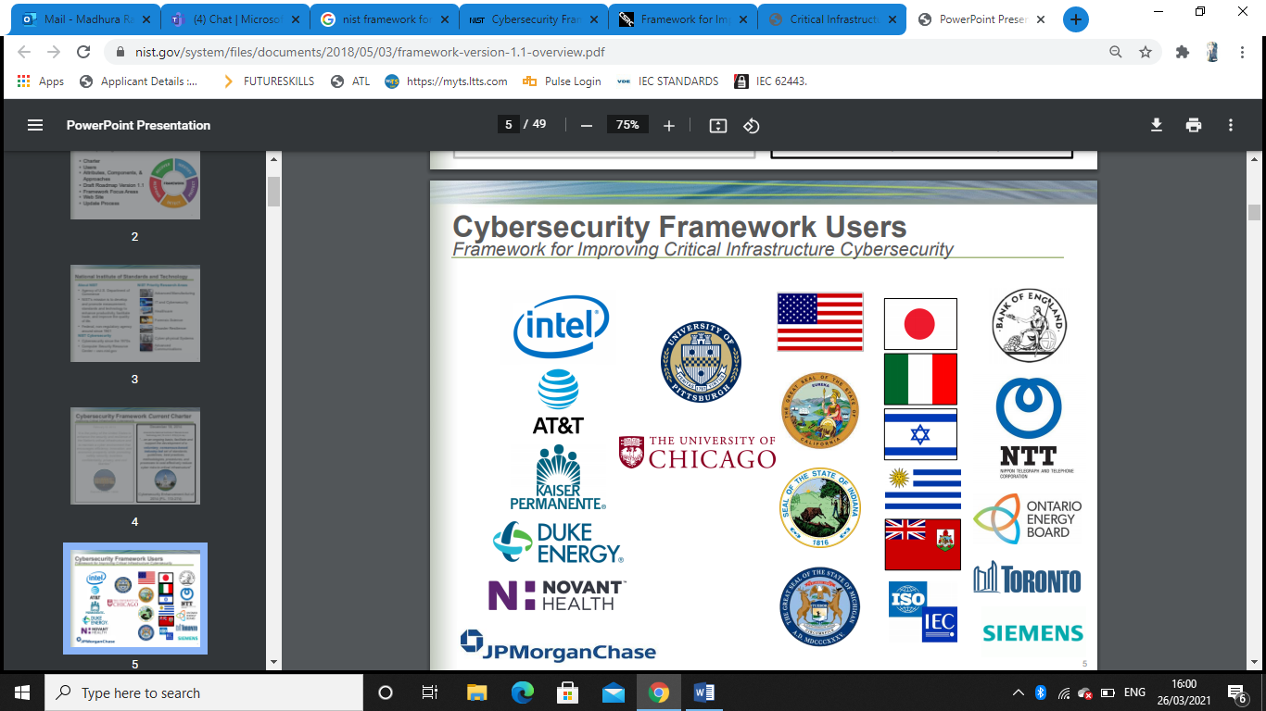

REFERENCES
https://www.nist.gov/cyberframework/online-learning/five-functions
https://www.nist.gov/system/files/documents/2018/05/03/framework-version-1.1-overview.pdf
https://nvlpubs.nist.gov/nistpubs/CSWP/NIST.CSWP.04162018.pdf

